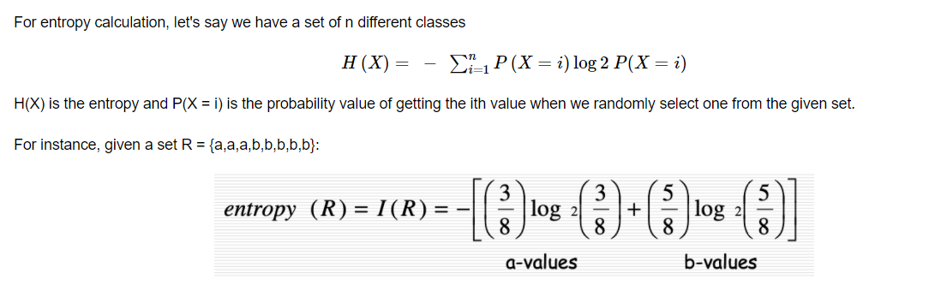

0.9544340029249649 (entropy <=1)

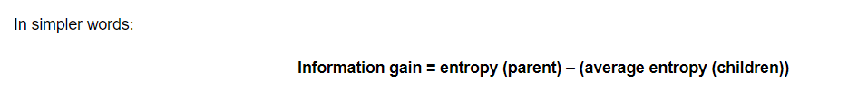

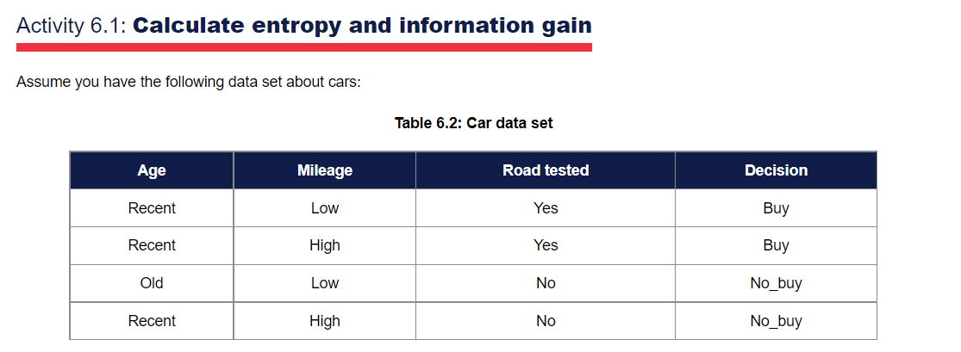

1. **Parent Entropy**:

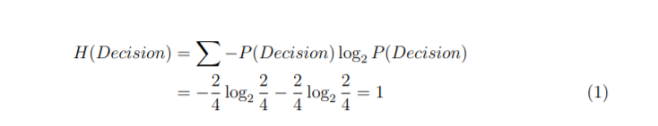

1. **Children entropy with Age**:

Entropy (Age = Recent):

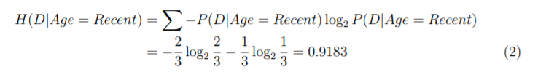

Entropy (Age = Old):

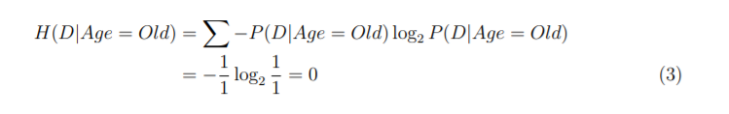

Average Entropy Age:

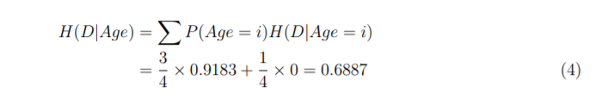

**Information gain : IG(Age) = 1 – 0.6887 = 0.3113**



1. **Children entropy with Mileage**

Entropy(Mileage=low):

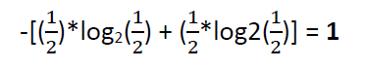

Entropy(Mileage=high):



Avg entropy Mileage:

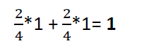

**IG(Mileage) = 1-1 = 0**



1. **Children entropy with Road test:**

Entropy(Roadtest=yes) = 0

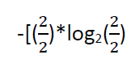

Entropy(Roadtest=no) = 0



Avg entropy Roadtest: = 0

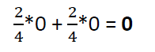

**IG(Roadtest) = 1 – 0 = 1**



**IG(Roadtest) = 1 – 0 = 1 -> root node**

**IG(Age) = 1 – 0.6887 = 0.3113 ->internal node**

**IG(Mileage) = 1-1 = 0 -->internal node**

Recent

Buy

Yes

Age

Road test

Recent

No_buy

Age

Old

No

No_buy

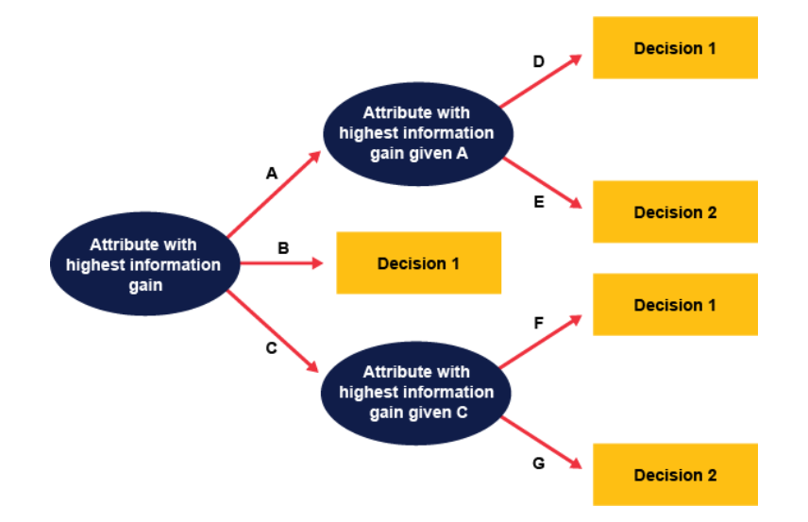

**Reference: University of Derby**